**Test Document for CR541-GH350-Handling of AS BUILT Drawing Release**

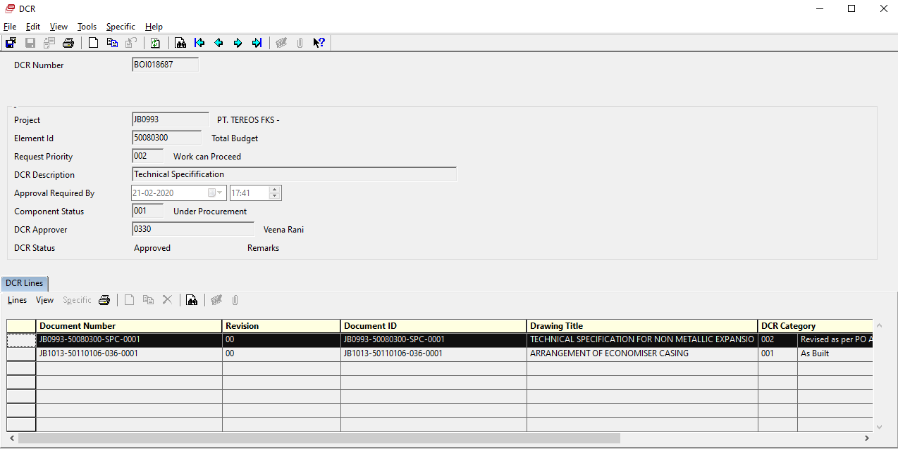

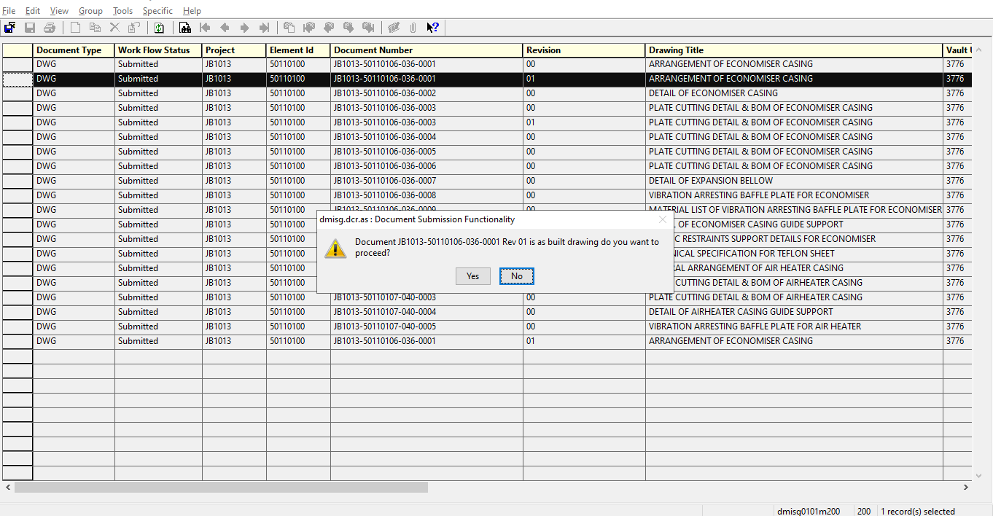

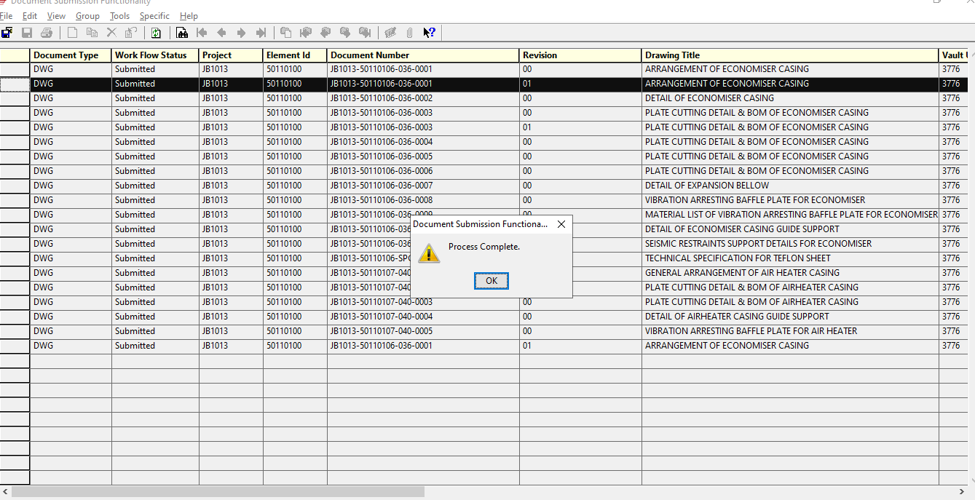

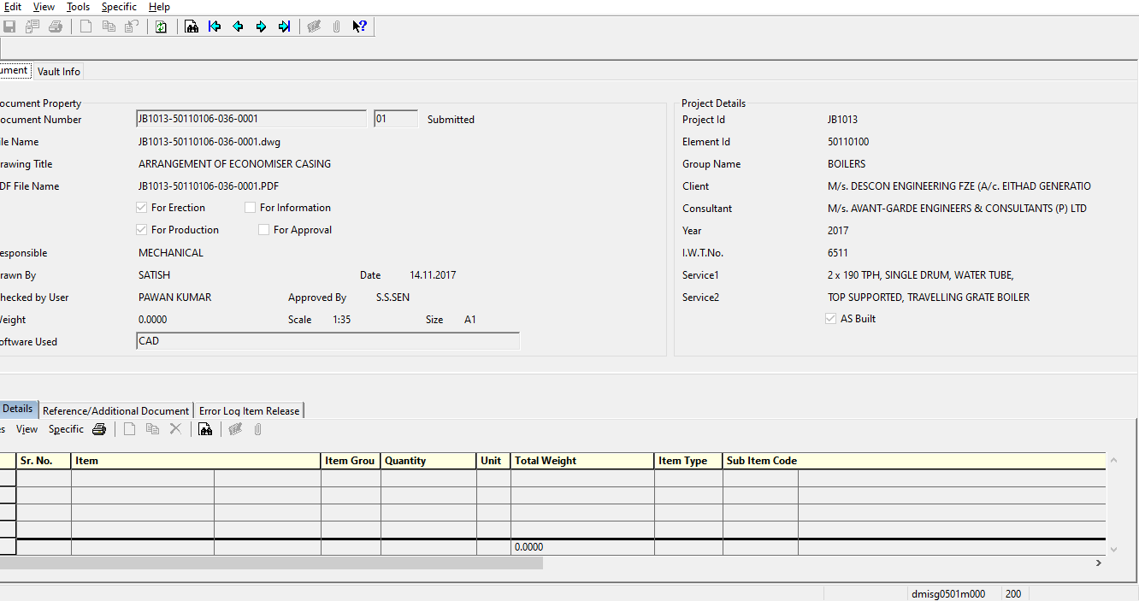

Reviewer Functionality:

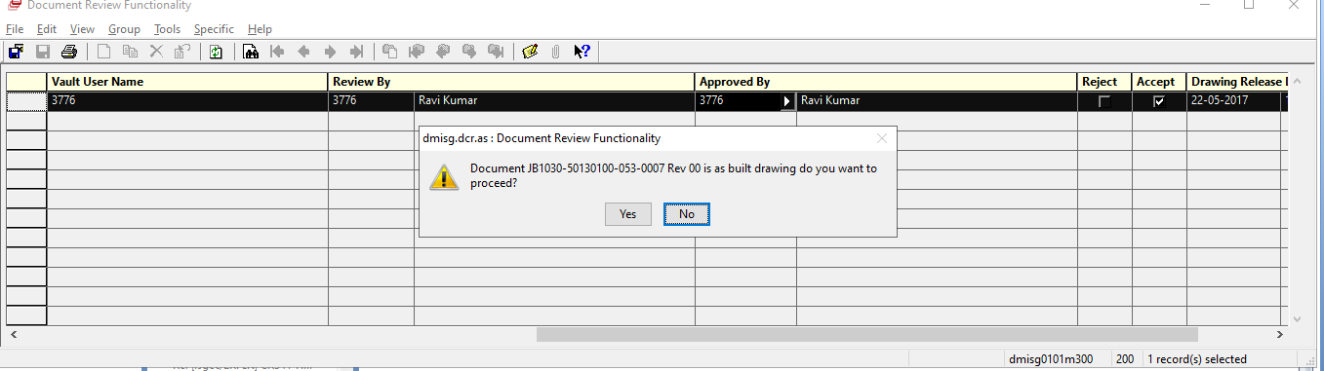

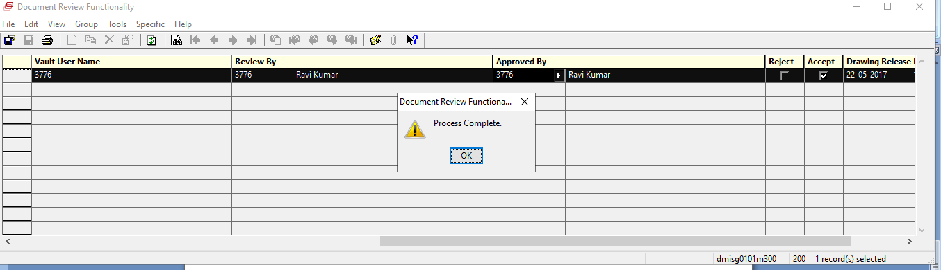

Approval Functionality:

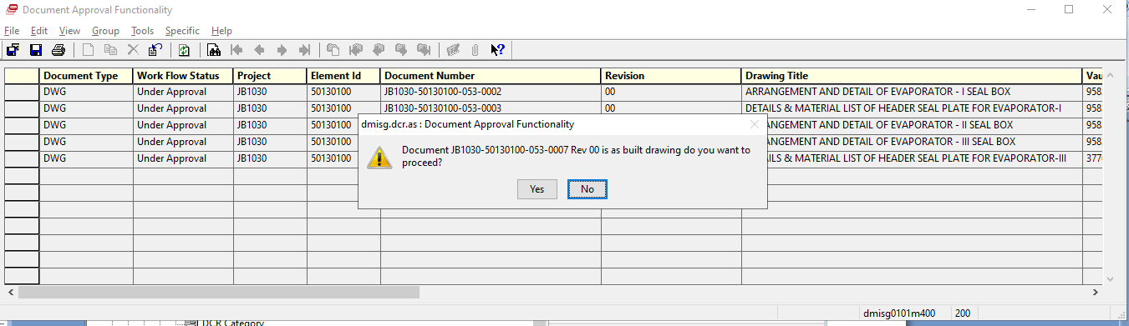

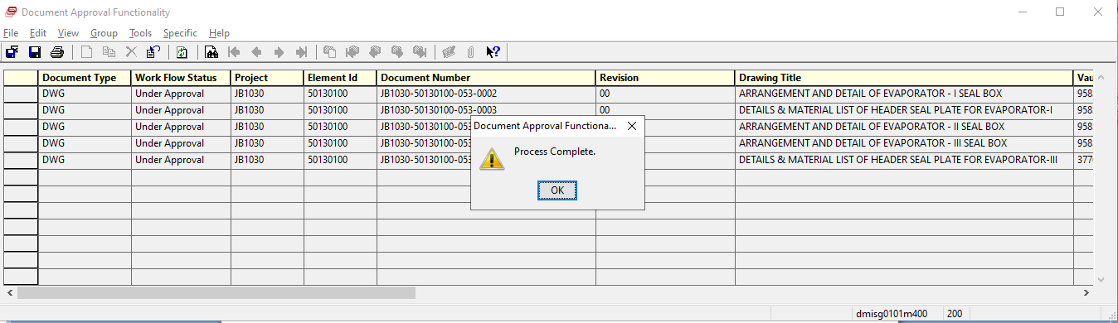

After changing S built as no by backend and then process the module



No